# Setting the environment

WAMP server

* A web server
* PHP
* MySql
* The link to follow http://www.wampserver.com/en/
* Editor
  + Macromedia Dreamweaver /Adobe Dreamweaver
* MSVCR100.dll is missing
  + Install Microsoft Visual C++ 2010 SP1 Redistributable Package
* Port conflict with skype: change port for skype

# PHP- an overview

* PHP: Hypertext Preprocessor
* Originally called “Personal Home Page Tools”
* Used to create dynamic web pages
* Popular server-side scripting technology
* Open-source
  + Anyone may view, modify and redistribute source code
* Platform independent
* Interpreted language, scripts are parsed at run-time rather than compiled beforehand
* Compatible with many popular databases
* Popular server-side scripting technology
* Structurally similar to C/C++
* Supports procedural and object-oriented paradigm

# How PHP fits with HTML

* Embedding PHP in HTML code
* HTML can also be written inside the PHP code
* PHP can also be written as a standalone program with no HTML at all

Basic syntax of PHP

* PHP code is denoted in the page with opening and closing tags, as follows:
  + <?php and ?>
  + <? or ?>
  + <script language=“PHP”>…… </script>
* PHP statements end with a semicolon
* Comments can be added as
  + // for one line comment
  + /* and */ for multiple lines comment

# Writing and executing PHP code

* Open a notepad or dreamweaver file
* Write PHP code
* Save file with .php extension
* Save all the files in one directory
* Copy this directory in
  + C:\wamp\www\
* Start WAMP server
* Go to localhost either by typing localhost in address bar of the browser or by clicking the WAMP sever icon in the toolbar and selecting localhost
* Select your web directory from the list of project on the WAMP server home page
* Select the file to execute

# Writing output to the browser

* echo(): is used to write output on the browser
  + echo(“Welcome to PHP”);
  + echo “Welcome to PHP”);
* print(): can also be used to write out put on the browser
  + print(“Welcome to PHP”);
  + print “Welcome to PHP”;
* printf(): can also be used for writing output

# First PHP code

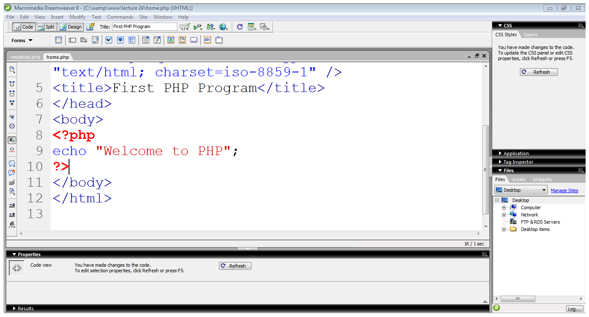

# Integrating HTML with PHP

* echo statement outputs whatever it’s told to the browser
* It can output not only plain text but also HTML tags
  + echo “<h1> Welcome to the PHP</h1>”;
* Using quotation marks:
  + echo “<h1 style=“color:red”> Welcome to PHP</h1>”;
  + echo “<h1 style=‘color:red’> Welcome to PHP</h1>”;
  + echo “<h1 style=\“color:red\”> Welcome to PHP</h1>”;

# Constants

* A constant is a placeholder for a value that you reference within your code that is formally defined before using it
* must begin with a letter or an underscore
* are case sensitive
* typically they are named using all capital letters
* PHP function define() is used to assign a value to a constant

# Variables

* Begin with $ sign
* First character must be a letter or underscore
* Remaining characters may be letters, numbers or underscores
* Don’t need to declare or initialize
* Case sensitive
* Data types does not require to be declare explicitly
* Supports
  + Float, integer, boolean, string, array, object
* The gettype() function returns the type of the provided variable
* The settype() function converts a variable to the type specified by type

# Type determination

* A number of functions are available for determining a variable’s type
  + boolean is_name(mixed var)
* is_array()
* is_bool()
* is_float()
* is_integer()
* is_null()
* is_numeric()
* is_string()